Week 4
- WebApi_Handson
First Web Api using .Net core

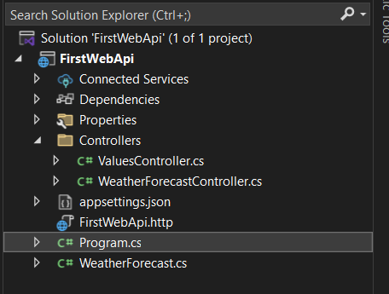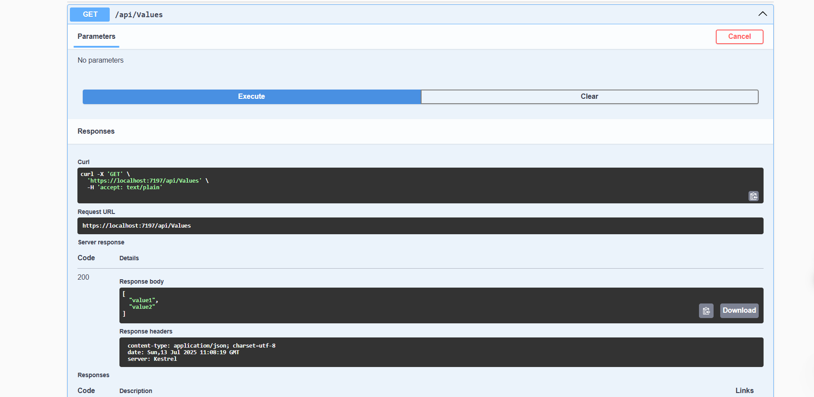

- WebApi_Handson
Web Api using .Net core with Swagger

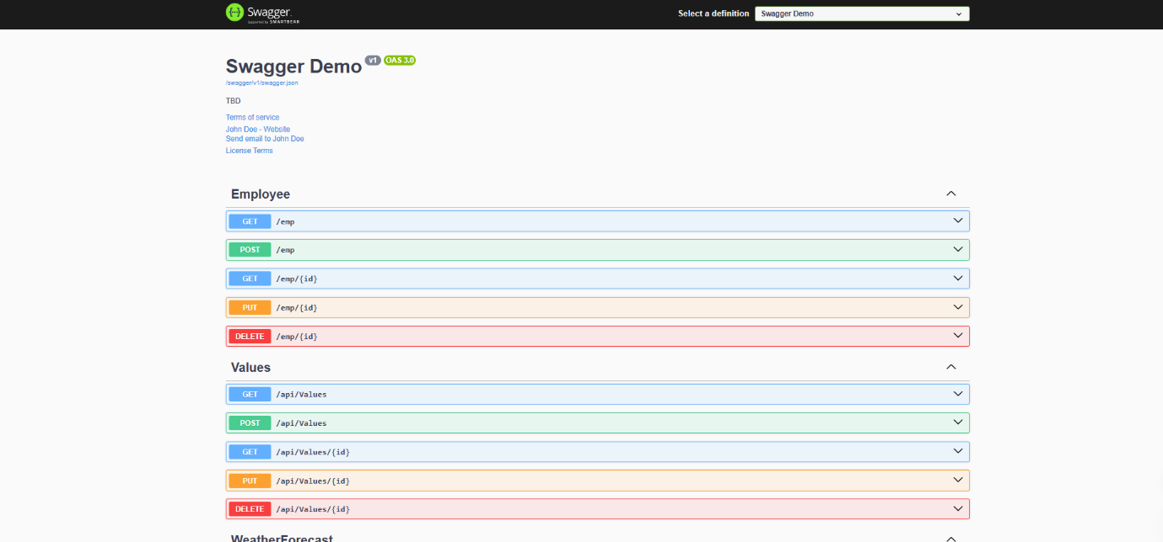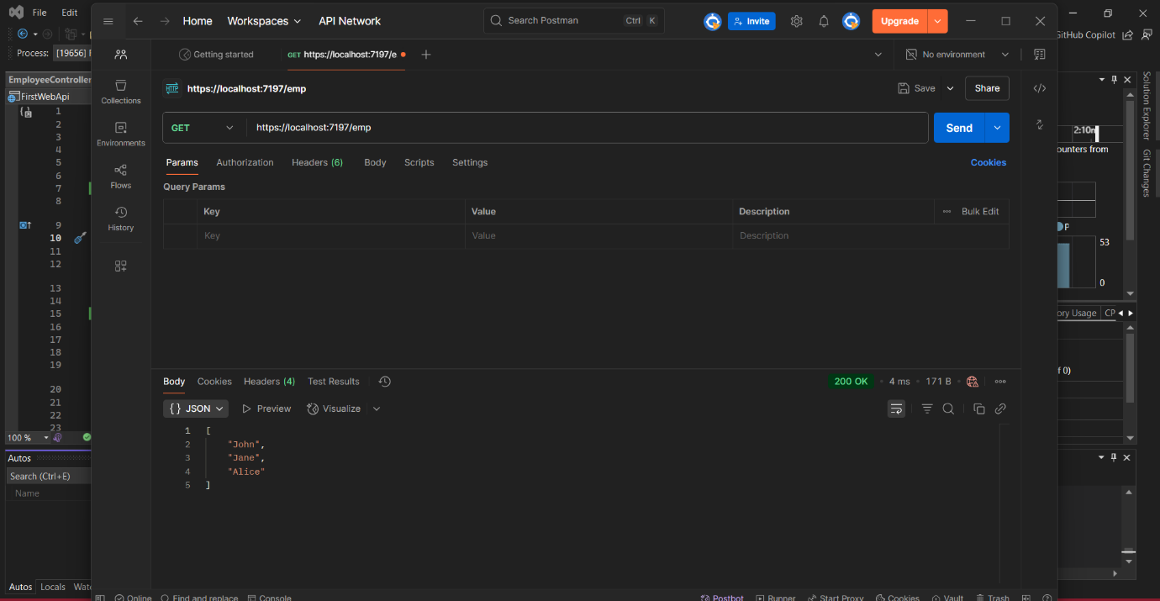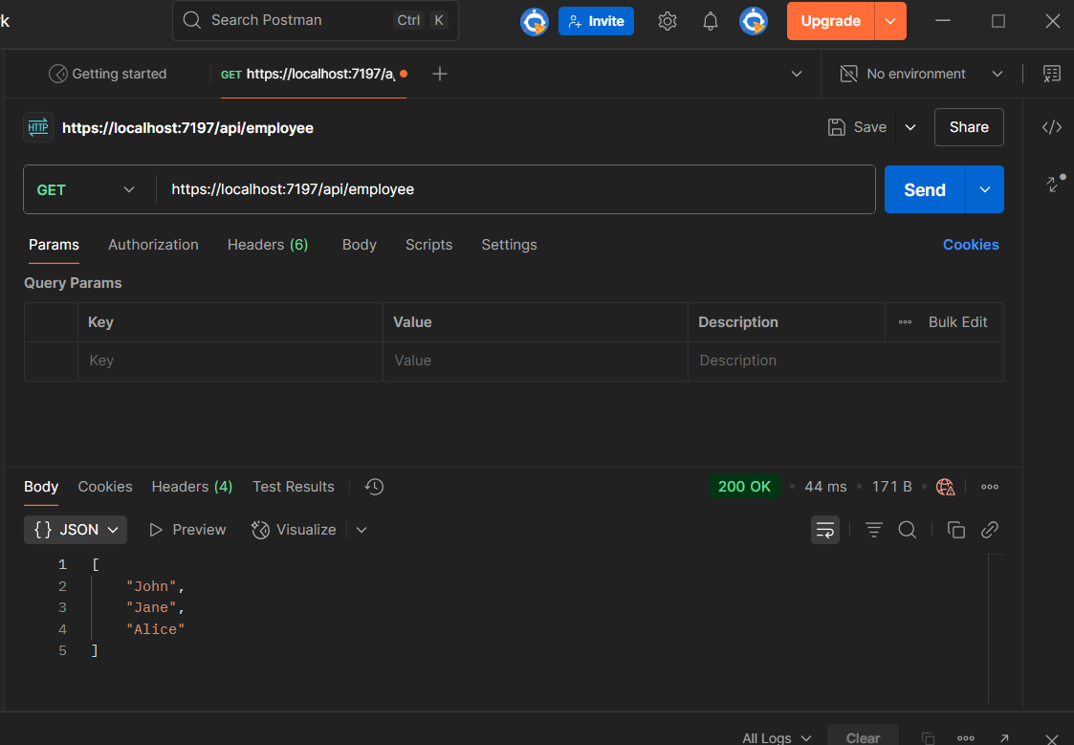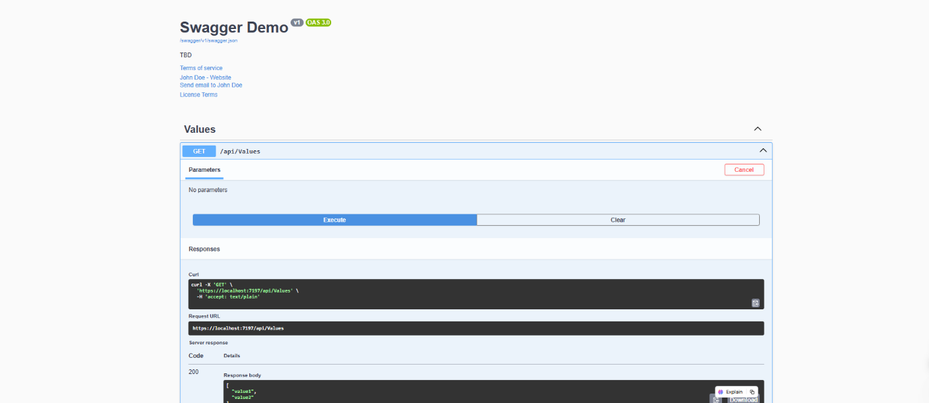
Employeecontroler.cs-

using Microsoft.AspNetCore.Mvc;

// For more information on enabling Web API for empty projects, visit https://go.microsoft.com/fwlink/?LinkID=397860

namespace FirstWebApi.Controllers
{
[Route("emp")]
[ApiController]
public class EmployeeController : ControllerBase
{
// GET: api/<EmployeeController>
[HttpGet]
public IEnumerable<string> Get()
{
return new string[] { "John", "Jane", "Alice" };
}

// GET api/<EmployeeController>/5
[HttpGet("{id}")]
public string Get(int id)
{
return "value";
}

// POST api/<EmployeeController>
[HttpPost]
public void Post([FromBody] string value)
{
}

// PUT api/<EmployeeController>/5
[HttpPut("{id}")]
public void Put(int id, [FromBody] string value)
{
}

// DELETE api/<EmployeeController>/5
[HttpDelete("{id}")]
public void Delete(int id)
{
}
}
}

Program.cs-

using Microsoft.OpenApi.Models;

namespace FirstWebApi
{
public class Program
{
public static void Main(string[] args)
{
var builder = WebApplication.CreateBuilder(args);

// Add services
builder.Services.AddControllers();

// Add Swagger
builder.Services.AddSwaggerGen(c =>
{
c.SwaggerDoc("v1", new OpenApiInfo
{
Title = "Swagger Demo",
Version = "v1",
Description = "TBD",
TermsOfService = new Uri("https://example.com/terms"),
Contact = new OpenApiContact
{
Name = "John Doe",
Email = "john@xyzmail.com",
Url = new Uri("https://www.example.com")
},
License = new OpenApiLicense
{
Name = "License Terms",
Url = new Uri("https://www.example.com")
}
});
});

var app = builder.Build();

// Configure middleware
if (app.Environment.IsDevelopment())
{
app.UseSwagger();
app.UseSwaggerUI(c =>
{
c.SwaggerEndpoint("/swagger/v1/swagger.json", "Swagger Demo");
});
}

app.UseHttpsRedirection();
app.UseAuthorization();
app.MapControllers();
app.Run();
}
}
}

- WebApi_Handson
i.Web Api using custom model class
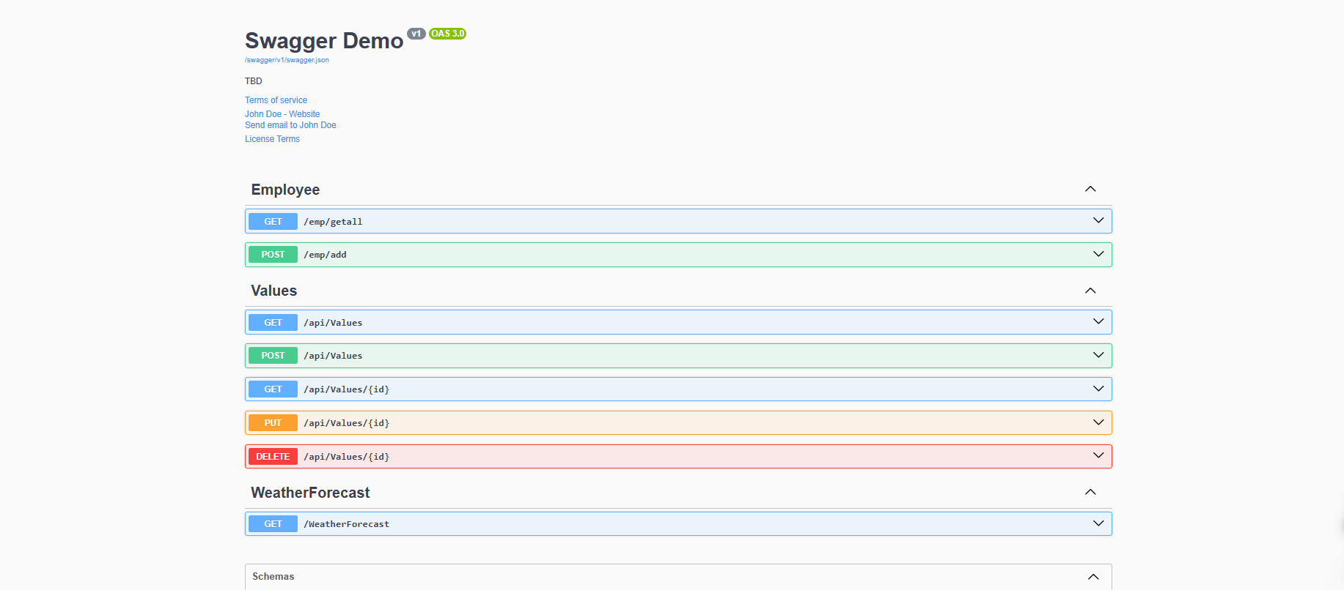
Employee.cs-
namespace FirstWebApi.Models
{
public class Employee
{
public int Id { get; set; }
public string Name { get; set; }
public int Salary { get; set; }
public bool Permanent { get; set; }
public Department Department { get; set; }
public List<Skill> Skills { get; set; }
public DateTime DateOfBirth { get; set; }
}

public class Department
{
public int DeptId { get; set; }
public string DeptName { get; set; }
}

public class Skill
{
public int SkillId { get; set; }
public string SkillName { get; set; }
}
}
EmployeeController.cs-
using FirstWebApi.Models;
using Microsoft.AspNetCore.Authorization;
using Microsoft.AspNetCore.Mvc;

namespace FirstWebApi.Controllers
{
[Route("emp")]
[ApiController]
public class EmployeeController : ControllerBase
{
private readonly List<Employee> _employees;

public EmployeeController()
{
_employees = GetStandardEmployeeList();
}

private List<Employee> GetStandardEmployeeList()
{
return new List<Employee>
{
new Employee
{
Id = 1,
Name = "John",
Salary = 50000,
Permanent = true,
Department = new Department { DeptId = 1, DeptName = "HR" },
Skills = new List<Skill>
{
new Skill { SkillId = 1, SkillName = "C#" },
new Skill { SkillId = 2, SkillName = "SQL" }
},
DateOfBirth = new DateTime(1990, 5, 24)
},
new Employee
{
Id = 2,
Name = "Jane",
Salary = 60000,
Permanent = false,
Department = new Department { DeptId = 2, DeptName = "IT" },
Skills = new List<Skill>
{
new Skill { SkillId = 3, SkillName = "JavaScript" }
},
DateOfBirth = new DateTime(1992, 8, 12)
}
};
}

[HttpGet("getall")]
[ProducesResponseType(StatusCodes.Status200OK)]
[AllowAnonymous]
public ActionResult<List<Employee>> GetStandard()
{
return Ok(_employees);
}

[HttpPost("add")]
[ProducesResponseType(StatusCodes.Status200OK)]
public ActionResult AddEmployee([FromBody] Employee newEmp)
{

_employees.Add(newEmp);
return Ok(newEmp);
}
}
}
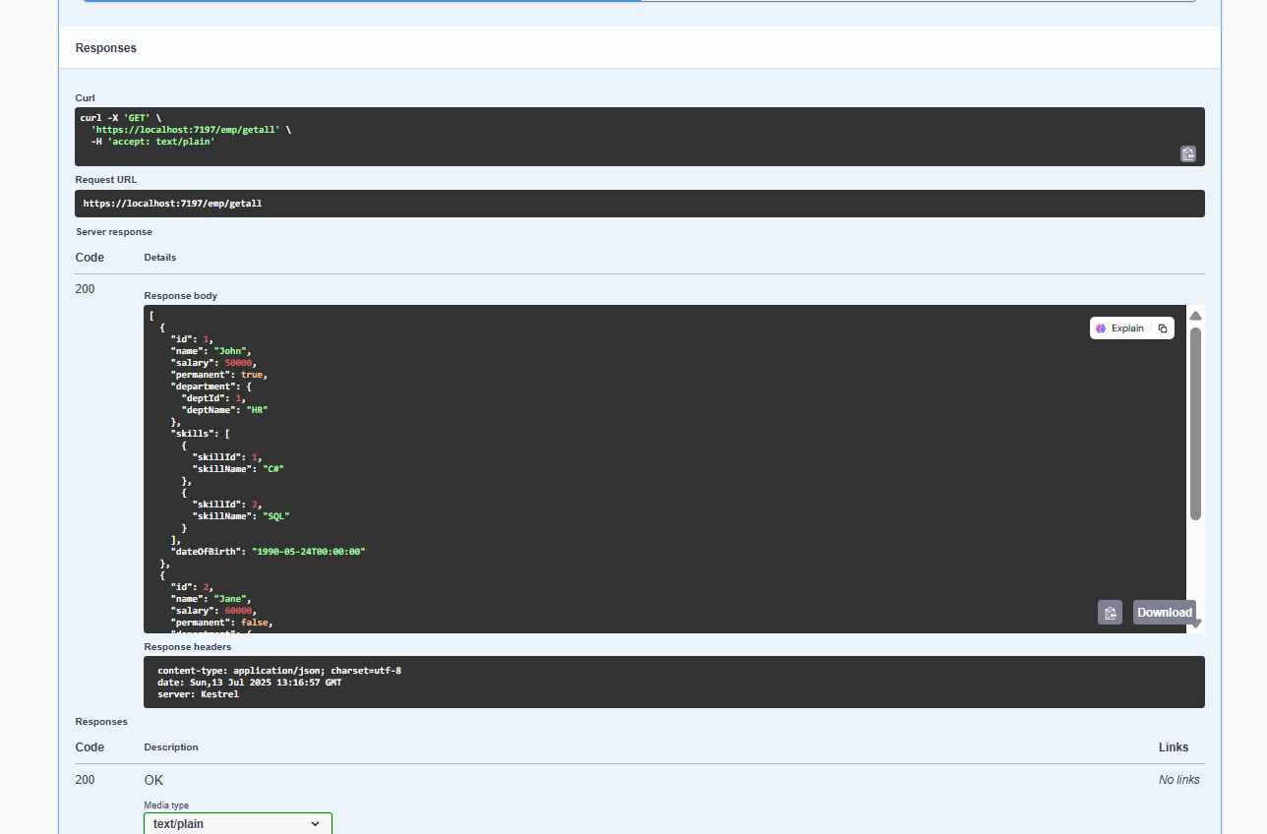
ii.Create a Custom action filter for Authorization-
CustomAuthFilter.cs-
using Microsoft.AspNetCore.Mvc;
using Microsoft.AspNetCore.Mvc.Filters;

namespace FirstWebApi.Filters
{
public class CustomAuthFilter : ActionFilterAttribute
{
public override void OnActionExecuting(ActionExecutingContext context)
{
var headers = context.HttpContext.Request.Headers;

if (!headers.ContainsKey("Authorization"))
{
context.Result = new BadRequestObjectResult("Invalid request - No Auth token");
return;
}

var token = headers["Authorization"].ToString();

if (!token.Contains("Bearer"))
{
context.Result = new BadRequestObjectResult("Invalid request - Token present but Bearer unavailable");
return;
}

base.OnActionExecuting(context);
}
}
}
Updated EmployeeController.cs-
using FirstWebApi.Models;
using Microsoft.AspNetCore.Authorization;
using Microsoft.AspNetCore.Mvc;
using FirstWebApi.Filters;

namespace FirstWebApi.Controllers
{
[Route("emp")]
[ApiController]
[CustomAuthFilter]
public class EmployeeController : ControllerBase
{
private readonly List<Employee> _employees;

public EmployeeController()
{
_employees = GetStandardEmployeeList();
}

private List<Employee> GetStandardEmployeeList()
{
return new List<Employee>
{
new Employee
{
Id = 1,
Name = "John",
Salary = 50000,
Permanent = true,
Department = new Department { DeptId = 1, DeptName = "HR" },
Skills = new List<Skill>
{
new Skill { SkillId = 1, SkillName = "C#" },
new Skill { SkillId = 2, SkillName = "SQL" }
},
DateOfBirth = new DateTime(1990, 5, 24)
},
new Employee
{
Id = 2,
Name = "Jane",
Salary = 60000,
Permanent = false,
Department = new Department { DeptId = 2, DeptName = "IT" },
Skills = new List<Skill>
{
new Skill { SkillId = 3, SkillName = "JavaScript" }
},
DateOfBirth = new DateTime(1992, 8, 12)
}
};
}

[HttpGet("getall")]
[ProducesResponseType(StatusCodes.Status200OK)]
[AllowAnonymous]
public ActionResult<List<Employee>> GetStandard()
{
return Ok(_employees);
}

[HttpPost("add")]
[ProducesResponseType(StatusCodes.Status200OK)]
public ActionResult AddEmployee([FromBody] Employee newEmp)
{

_employees.Add(newEmp);
return Ok(newEmp);
}
}
}
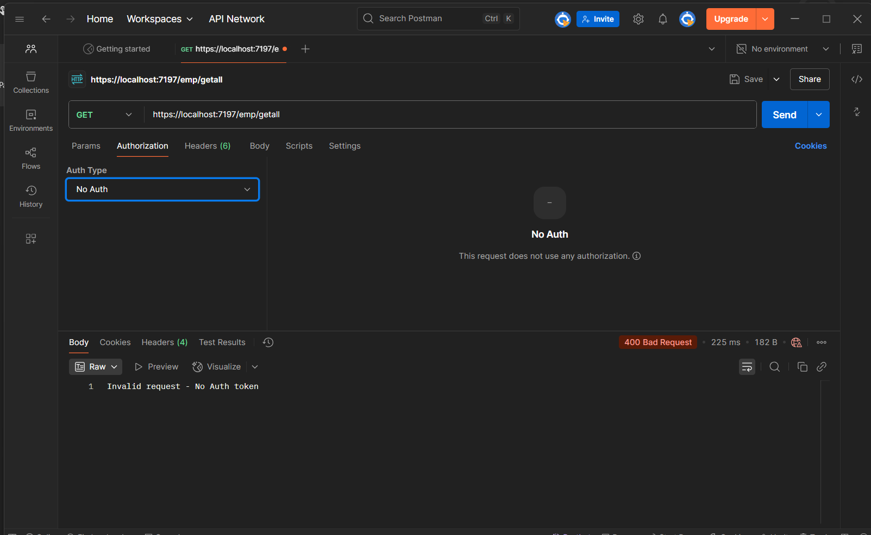

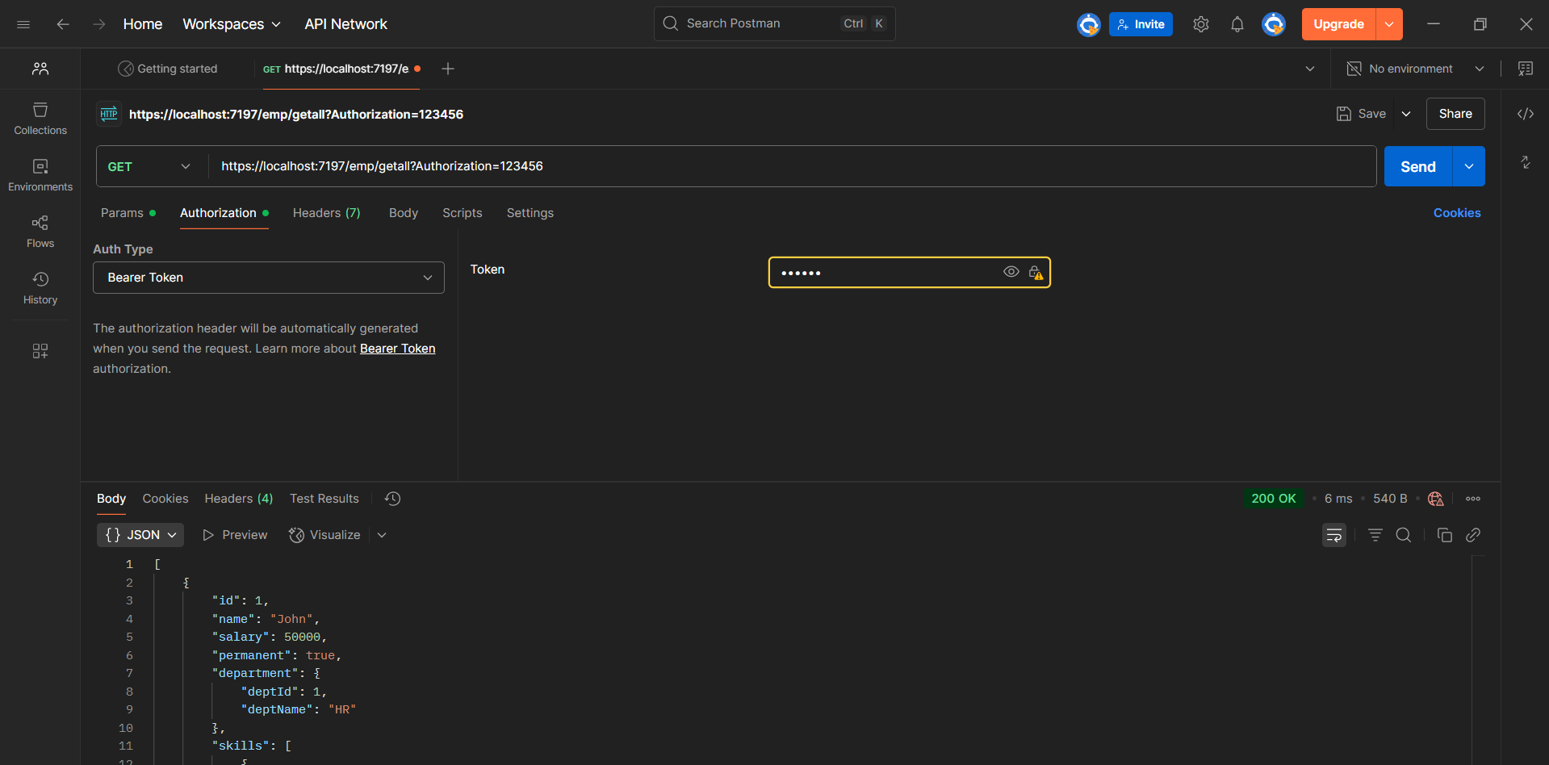
iii.Custom Exception filter-
CustomExceptionFilter-
using Microsoft.AspNetCore.Mvc;
using Microsoft.AspNetCore.Mvc.Filters;

namespace FirstWebApi.Filters
{
public class CustomExceptionFilter : IExceptionFilter
{
public void OnException(ExceptionContext context)
{

var exception = context.Exception;

var logPath = Path.Combine(Directory.GetCurrentDirectory(), "log.txt");
File.AppendAllText(logPath, $"[{DateTime.Now}] {exception.Message}{Environment.NewLine}");

context.Result = new ObjectResult("Internal Server Error occurred. Please contact support.")
{
StatusCode = 500
};
}
}
}
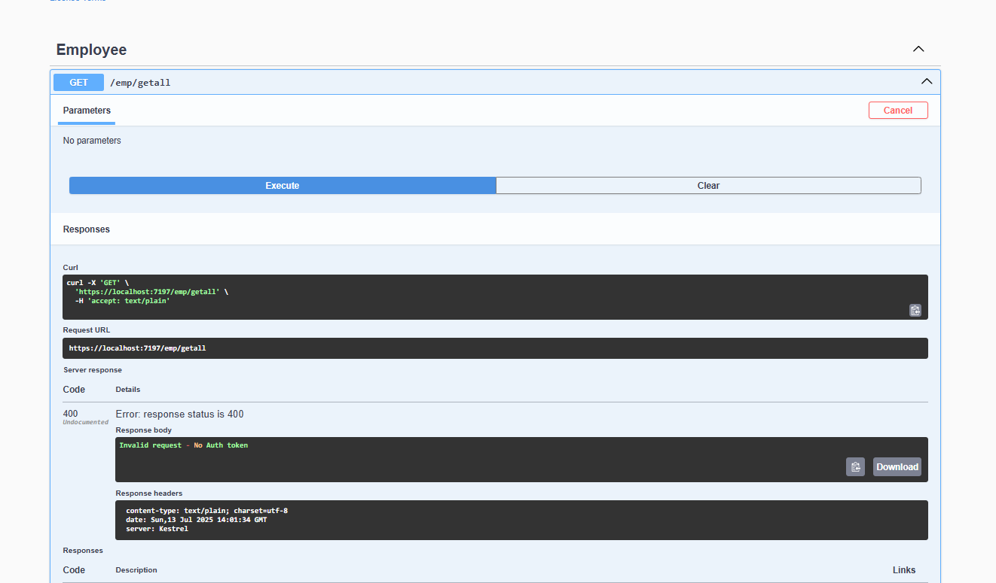
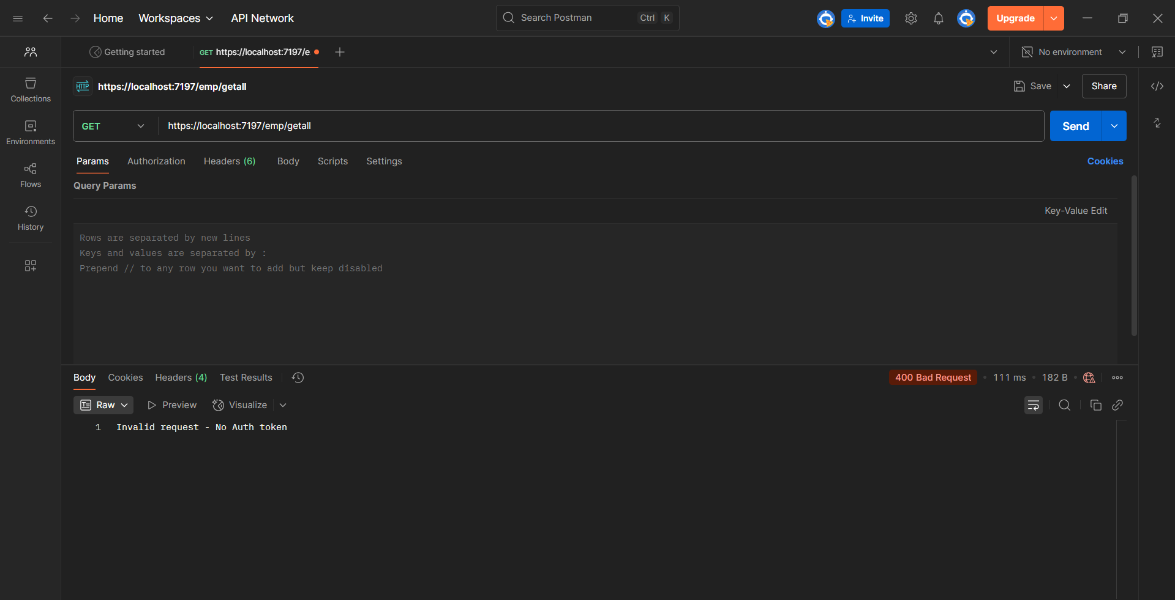

- WebApi_Handson
Web Api CRUD operation-
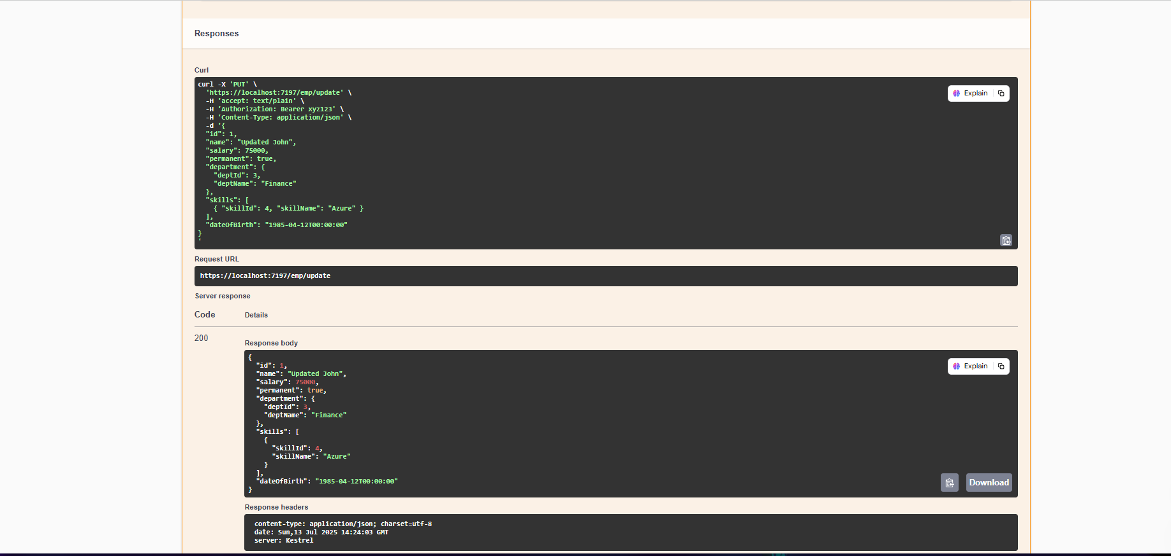
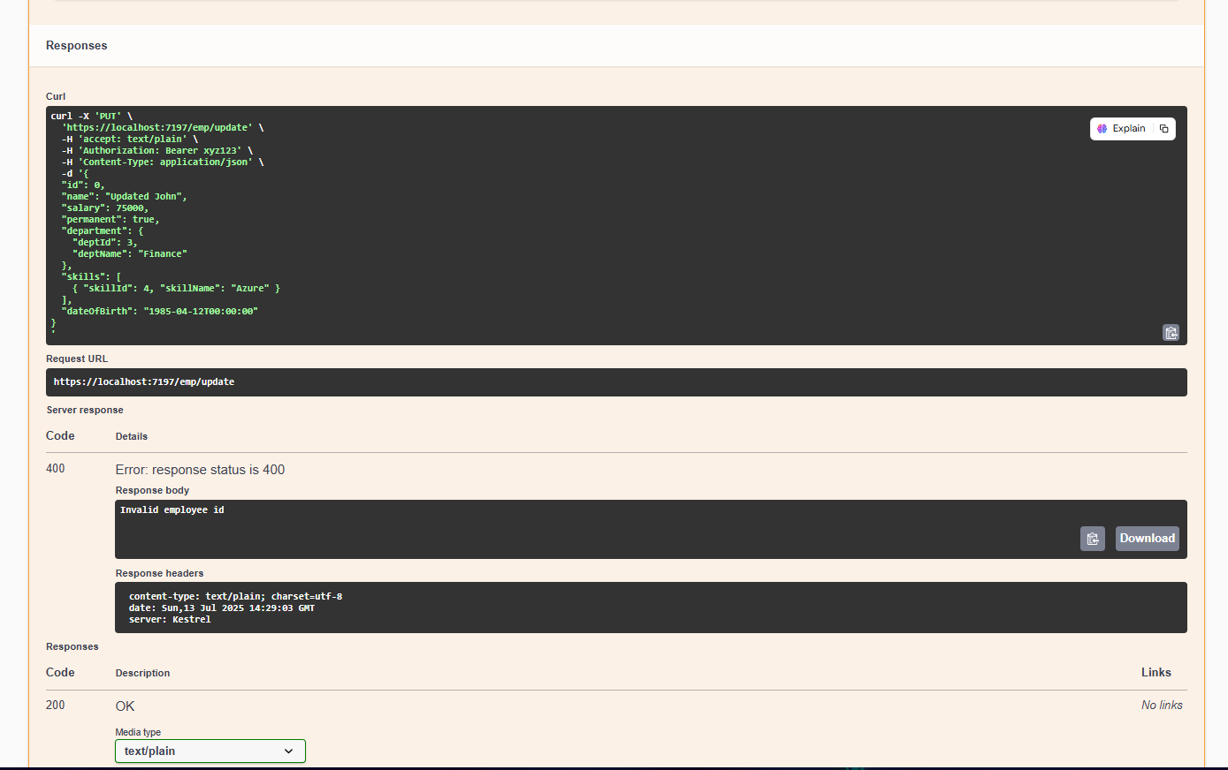

Added in program.cs-
[HttpPut("update")]
[ProducesResponseType(StatusCodes.Status200OK)]
[ProducesResponseType(StatusCodes.Status400BadRequest)]
public ActionResult<Employee> UpdateEmployee([FromBody] Employee updatedEmp)
{
if (updatedEmp.Id <= 0)
{
return BadRequest("Invalid employee id");
}

var existingEmp = _employees.FirstOrDefault(e => e.Id == updatedEmp.Id);
if (existingEmp == null)
{
return BadRequest("Invalid employee id");
}

existingEmp.Name = updatedEmp.Name;
existingEmp.Salary = updatedEmp.Salary;
existingEmp.Permanent = updatedEmp.Permanent;
existingEmp.Department = updatedEmp.Department;
existingEmp.Skills = updatedEmp.Skills;
existingEmp.DateOfBirth = updatedEmp.DateOfBirth;

return Ok(existingEmp);

[HttpDelete("delete/{id}")]
[ProducesResponseType(StatusCodes.Status200OK)]
[ProducesResponseType(StatusCodes.Status400BadRequest)]
[ProducesResponseType(StatusCodes.Status404NotFound)]
public ActionResult<Employee> DeleteEmployee(int id)
{
if (id <= 0)
{
return BadRequest("Invalid employee id");
}

var empToDelete = _employees.FirstOrDefault(e => e.Id == id);
if (empToDelete == null)
{
return NotFound("Employee not found");
}

_employees.Remove(empToDelete);
return Ok(empToDelete);
}

- WebApi_Handson
Updated program.cs-
using Microsoft.AspNetCore.Authentication.JwtBearer;
using Microsoft.IdentityModel.Tokens;
using System.Text;

var builder = WebApplication.CreateBuilder(args);

// JWT setup
string securityKey = "mysuperdupersecret";
var symmetricSecurityKey = new SymmetricSecurityKey(Encoding.UTF8.GetBytes(securityKey));

builder.Services.AddAuthentication(x =>
{
x.DefaultAuthenticateScheme = JwtBearerDefaults.AuthenticationScheme;
x.DefaultChallengeScheme = JwtBearerDefaults.AuthenticationScheme;
})
.AddJwtBearer(JwtBearerDefaults.AuthenticationScheme, x =>
{
x.TokenValidationParameters = new TokenValidationParameters
{
ValidateIssuer = true,
ValidateAudience = true,
ValidateLifetime = true,
ValidateIssuerSigningKey = true,
ValidIssuer = "mySystem",
ValidAudience = "myUsers",
IssuerSigningKey = symmetricSecurityKey
};
});

builder.Services.AddControllers();
builder.Services.AddEndpointsApiExplorer();
builder.Services.AddSwaggerGen();

var app = builder.Build();

if (app.Environment.IsDevelopment())
{
app.UseSwagger();
app.UseSwaggerUI();
}

app.UseHttpsRedirection();
app.UseAuthentication(); //
app.UseAuthorization();
app.MapControllers();
app.Run();

AuthController.cs-
using Microsoft.AspNetCore.Mvc;
using Microsoft.IdentityModel.Tokens;
using System.IdentityModel.Tokens.Jwt;
using System.Security.Claims;
using System.Text;

namespace FirstWebApi.Controllers
{
[ApiController]
[Route("auth")]
[AllowAnonymous]
public class AuthController : ControllerBase
{
[HttpGet("token")]
public IActionResult GetToken()
{
var token = GenerateJSONWebToken(101, "Admin");
return Ok(new { token });
}

private string GenerateJSONWebToken(int userId, string userRole)
{
var securityKey = new SymmetricSecurityKey(Encoding.UTF8.GetBytes("mysuperdupersecret"));
var credentials = new SigningCredentials(securityKey, SecurityAlgorithms.HmacSha256);

var claims = new List<Claim>
{
new Claim(ClaimTypes.Role, userRole),
new Claim("UserId", userId.ToString())
};

var token = new JwtSecurityToken(
issuer: "mySystem",
audience: "myUsers",
claims: claims,
expires: DateTime.Now.AddMinutes(10),
signingCredentials: credentials);

return new JwtSecurityTokenHandler().WriteToken(token);
}
}
}
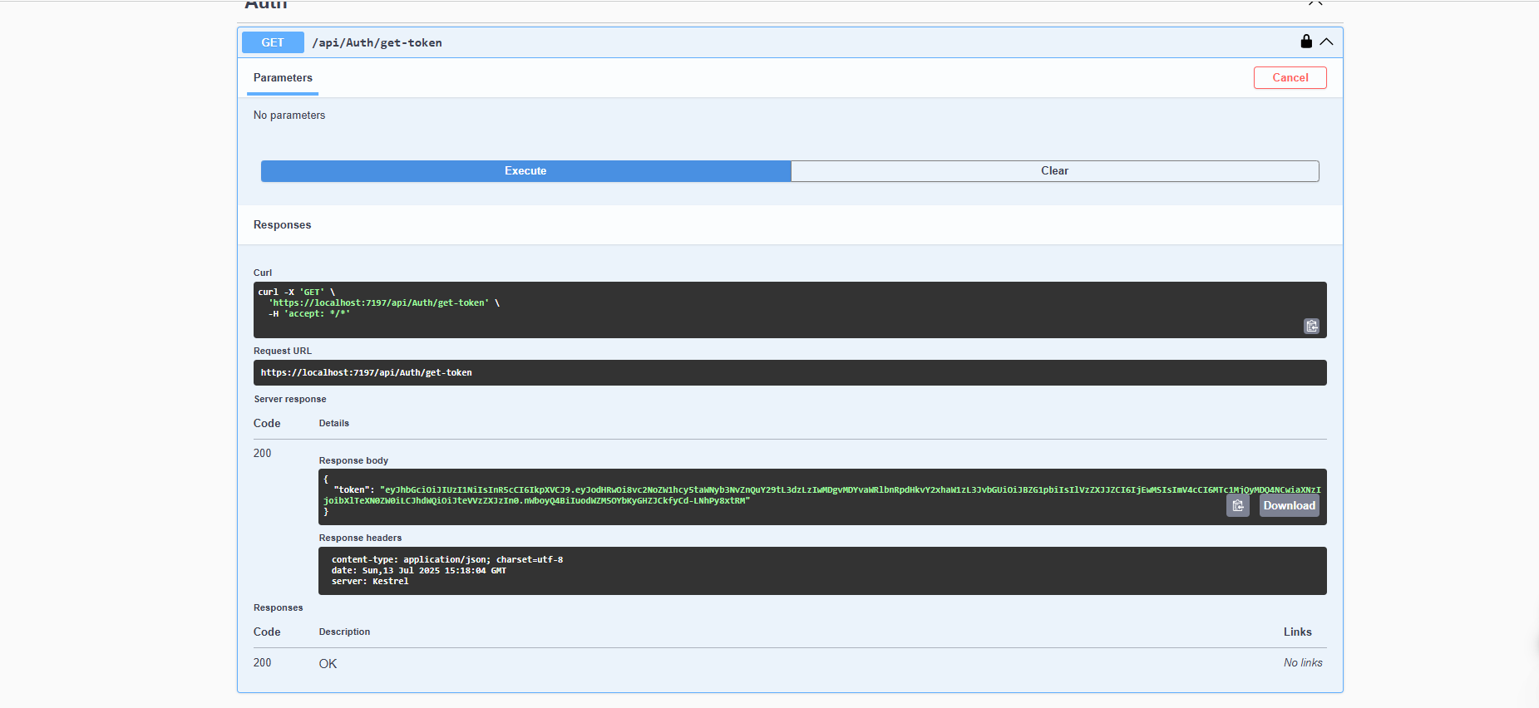
Received token
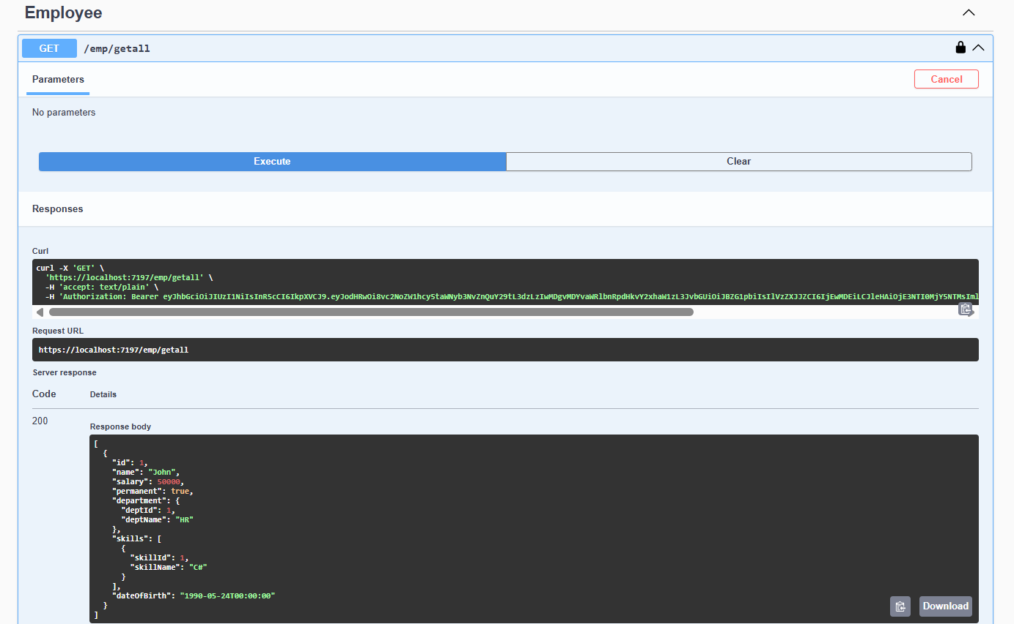

Check for JWT expiration

//expires: DateTime.Now.AddMinutes(2)
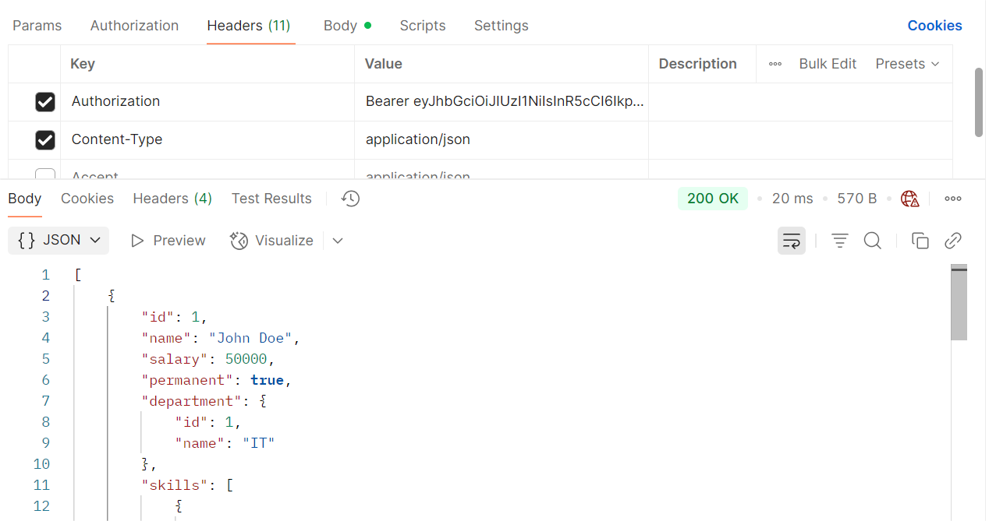
Token within 2min
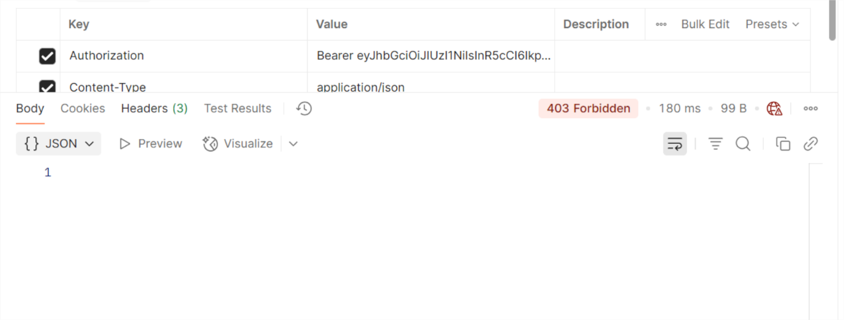
Tocken after 2 min
Add Role-Based Authorization

In EmployeeController.cs-
[Authorize(Roles = "Admin,POC")] // Add roles to [Authorize] in EmployeeController
In AuthController.cs-
// Modifed AuthController to test role filtering

[HttpGet("GetToken")]
[AllowAnonymous]
public IActionResult GetToken()
{
string token = GenerateJSONWebToken(1001, "POC");
return Ok(token);
}
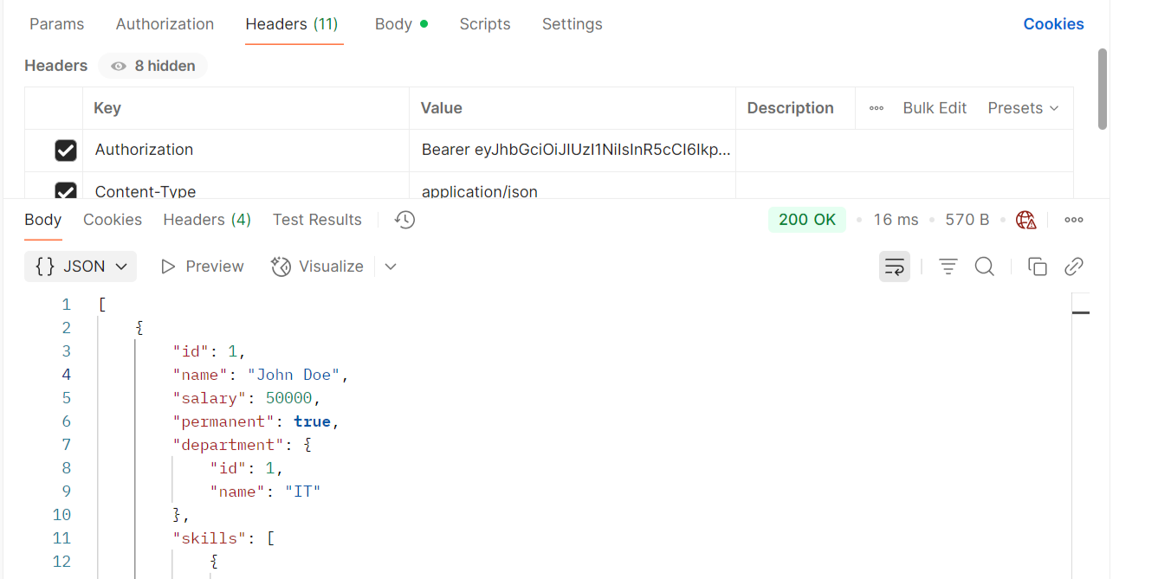
Poc token with poc,admin
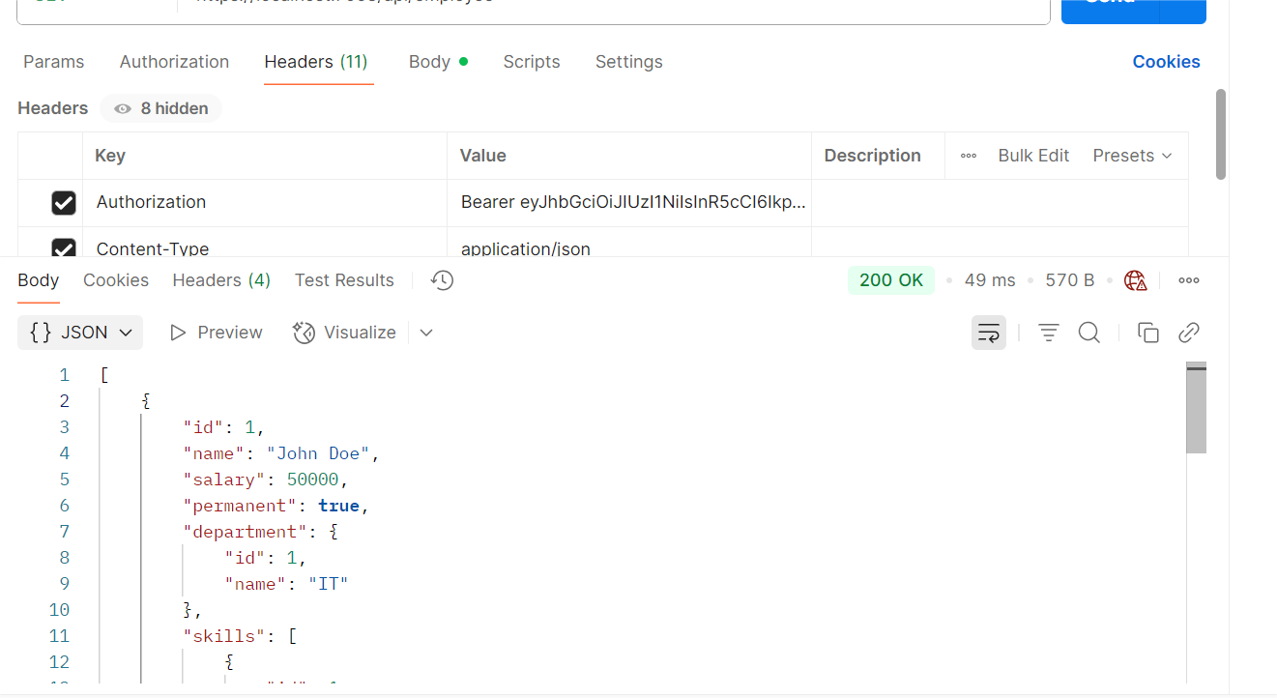
Poc token with poc
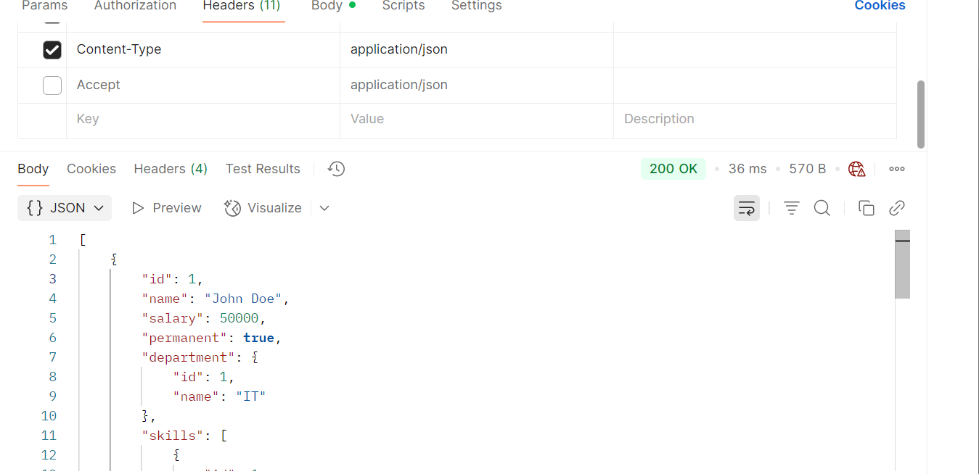
Admin token with admin,poc
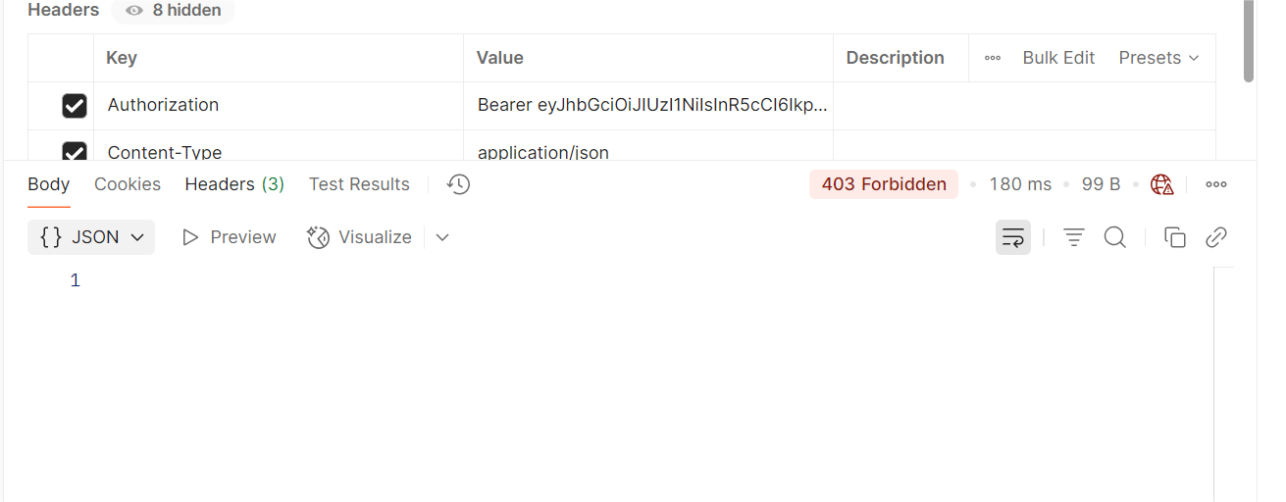
Admin token with poc

